# E-Vehicle Routing with Parking System

Aryaman Mishra, Dr. Suguna M

B.Tech CSE, VIT Chennai

**Abstract-** The expanding demand in major cities is outpacing the capacity of the current transportation system. For daily commuters, short-distance transit has emerged as an unresolved problem. The instance illustrates how EVs have become a viable alternative mode of transportation for addressing daily commuters' concerns about first-mile connectivity, last-mile connectivity, and quick trips to their destination. EVs are essentially cars and bikes that on normal capacity cause less carbon emission and can be used for intra and intercity commute. Cars, Bicycles, e-bikes, skateboards, hoverboards, and other battery-powered vehicles are some of these. An electric vehicle venture promotes the concept of green consumerism among the daily commuters at affordable rates. Recently, E-vehicles systems are being found to have been damaged by users due to inconsistent routes, mechanical problems and driver errors. Thus, this project intends to create a tool for damage limitation and optimize routing of such E-vehicles.

**Index Terms**- E-Vehicle, Routing, Parking, Battery

1. Introduction

Electric vehicles have been gaining traction in India as a sustainable and eco-friendly alternative to traditional gasoline-powered vehicles. The Indian government has set ambitious targets for the adoption of EVs, with a goal of 30% of all vehicles on the road being electric by 2030. In this abstract, we will explore the current state of EV usage in India, the challenges facing the widespread adoption of EVs, and potential solutions to these challenges. One major challenge facing the adoption of EVs in India is the lack of infrastructure to support them. This includes a lack of charging stations, as well as the limited availability of EV models in the country. Additionally, the high cost of EVs compared to traditional gasoline vehicles is a major barrier to widespread adoption. In cities having the availabilities of E-vehicles, we are going to create an AI function to map the optimal route in a provided city landscape structure to avoid damage, engine stagnation, battery leakage and discharge by providing users the route to their destination on a pointto-point basis which allows them to reach their destinations on time with the integrity of the structure of the E-Vehicle intact. To address these challenges, the Indian government has implemented several policies and initiatives to promote the use of EVs. These include financial incentives for manufacturers and consumers, as well as the construction of charging infrastructure. The government is also working to increase the availability of EV models in the country, and encouraging research and development in the EV industry. Another key solution is the collaboration between public and private sector, and the use of PPP to develop EV infrastructure and promote EV adoption. The adoption of EVs in India has the potential to significantly reduce the country's dependence on fossil fuels and improve air quality. However, significant challenges must be overcome to achieve widespread adoption of EVs, including the lack of infrastructure and the high cost of EVs. With the right policies and initiatives in place, however, India can become a leader in the adoption of EVs and pave the way for a more sustainable future.

When comparing routing algorithms, it is important to consider factors such as computational complexity, ability to handle large amounts of data, ability to find the shortest path, and ability to handle real-time data. Dijkstra's algorithm is a popular algorithm that is known for its ability to find the shortest path in a graph. It has a time complexity of O(n log n) and is suitable for use in small to medium-sized networks.

Bellman-Ford algorithm is a popular algorithm that can handle negative edge weights and is suitable for use in large networks. It has a time complexity of O(n*m) and is known for its ability to detect negative cycles.

A* algorithm is an extension of Dijkstra's algorithm that uses heuristics to improve its performance. It is known for its ability to find the shortest path in a graph with a time complexity of O(b^d) where b is the branching factor and d is the depth of the solution.

Floyd-Warshall algorithm is an algorithm that can be used to find the shortest path between all pairs of nodes in a graph. It has a time complexity of O(n^3) and is suitable for use in small to medium-sized networks.

In general, Dijkstra's algorithm and A* algorithm are suitable for use in small to medium-sized networks, while Bellman-Ford algorithm and Floyd-Warshall algorithm are suitable for use in large networks. A* algorithm is more suitable when the graph has a large branching factor and is more efficient than Dijkstra's algorithm when the heuristics are accurate. Bellman-Ford algorithm is suitable when the graph has negative edge weights.

It is important to note that the choice of algorithm will depend on the specific requirements of the application and the characteristics of the network.

Electric vehicles (EVs) have gained attention in recent years as a sustainable and eco-friendly alternative to traditional gasoline-powered vehicles. One of the key challenges facing the widespread adoption of EVs is the limited range and the lack of charging infrastructure. Routing algorithms and techniques can help to address these challenges by optimizing the routing of EVs to charging stations and minimizing the impact of range limitations.

1. LITERATURE SURVEY

A study by the IEA found that India had one of the lowest numbers of public charging points per EV in the world, with only 0.03 public charging points per EV in 2018[1]. Another study by the Confederation of Indian Industry (CII) and Deloitte found that only 0.1% of cars on Indian roads were electric in 2018[2].A study by the National Institution for Transforming India (NITI Aayog) found that the government's policies had led to a significant increase in EV sales, with the number of EVs on Indian roads projected to reach 30-40 million by 2030[3]. A study by the Energy and Resources Institute found that PPPs could be an effective way to finance the development of EV charging infrastructure in India[4].Research on EVs in India has highlighted the challenges facing the widespread adoption of EVs, including the lack of infrastructure and the limited availability of EV models. However, it also suggests that government policies and initiatives, as well as collaborations between the public and private sectors, have the potential to overcome these challenges and promote the widespread adoption of EVs in India.

In a study,the traditional capacitated vehicle routing problem is extended to include cumulative vehicle routing problems, which seek to identify a set of delivery routes that optimize a given objective function while taking cost accumulation into account during the planning and implementation process. The paper suggested the usage of a modified Bellman-Ford algorithm. The algorithm did a bottom-up calculation of the shortest pathways. The shortest distances with a maximum of one edge in the path were first calculated. It then determined the shortest pathways with a maximum of two edges, and so forth. The shortest pathways with a maximum of I edges were determined following the i-th iteration of the outer loop. Any simple path could have a maximum of |V| - 1 edges, therefore the outer loop ran |v| - 1 times. The theory states that if we have determined the shortest paths with at most I edges, and there isn't a negative weight cycle, then iterating over all edges will result in the shortest path with at most (i+1) edges[5].

In another paper,a nonlinear electric energy consumption model based on typical driving cycles of suburban and urban areas was created, taking into account the vehicle load, travel distance, and speed. This was done because energy consumption may have had an impact on the maximum driving range and charging behavior of EVs. After that, a problem-solving adaptive particle swarm optimization method was created. The two properties of a particle were location and velocity. The swarm explored an n-dimensional space in quest of the optimal answer.A particle's position serves as a representation of a solution, and its velocity was modified to look for other solutions. The best position the particle has ever attained is recorded, while the best position the entire swarm has ever experienced was also recorded and updated after each iteration[6].

Following the use of the PPO approach , which is a member of the Actor-Critic class of reinforcement learning methods, the Routing problem is described as a Markov Decision Process (MDP). In a subsequent step, the brain architecture underlying the Actor and the Critic was established. For both the Actor and the Critic, it was decided to use a neural architecture based on convolutional neural networks. This decision led to the efficient handling of issues of various magnitude. Experiments on a variety of situations demonstrate that the method is capable of good generalisation and can arrive at good answers quickly. Comparisons between the suggested method and the cutting-edge solver OR-TOOLS reveal that the latter still performs better than the algorithm for reinforcement learning. It formalizes the limitation as a penalty in the objective function rather than imposing a strict constraint. It can use a firstorder optimizer, such as the Gradient Descent method, to maximise the objective by choosing not to completely avoid the restriction[7].

Another study Solves the problem of routing a personal electric car and provides the best route for a single vehicle on a lengthy origin-to-destination (OD) trip. The total trip time and the total cost of charging are reduced by multi-objective optimization. Additionally, it adds external and real-world aspects like charging station traffic, travel times to reach a charging station, and fluctuating electricity prices at various charging stations into the formulation of the problem. The genetic algorithm, which is based on natural selection, the mechanism that propels biological evolution, is a technique for resolving both limited and unconstrained optimization issues. A population of unique solutions is repeatedly modified by the genetic algorithm.

One of the bio-inspired algorithms, particle swarm optimization (PSO), is straightforward in its search for the best solution in the problem area. It differs from other optimization techniques in that it does not depend on the gradient or any differential form of the objective and simply requires the objective function[8].

Another study provides a thorough analysis of EV routing issues and their many solutions. Electric travelling salesman problem, green VRP, electric VRP, mixed electric VRP, electric location routing problem, hybrid electric VRP, electric problem, electric two-echelon VRP, and electric pickup and delivery problem are some examples of problem types and solutions[9].

In another work, the EV charging scheduling problem is studied, with the goal of minimizing the total elapsed time, which includes charging time for EVs. To achieve this goal, the charging path routing and charging station selection are simultaneously optimised. Algorithms used includes scheduling algorithms based on Stack and Queues depending on geographical location of station and area of commute[10].

Another work proposes a mathematical description of the EV-specific routing problem in a graph-theoretical setting that takes into account EVs' capacity for energy recovery. On a road network, an off-policy model-free reinforcement learning technique is utilized to create EV energy-feasible pathways from source to target. Djikstra’s Algortihm was mainly used for this purposes[11].

A study gives a thorough overview of the application of deep neural networks and supervised and unsupervised machine learning for the analysis and prediction of charging behaviour[12].

In yet another case study,delivery of packages is taken into account, as are indicators for driver and time reliability, backhauling, and cost effectiveness. Recharging operations for electric cars are scheduled[13].

A study briefly introduces EVRP models that take battery losses into account; second, EVRP models are divided into four categories based on the composition of the EVRP objective function and constraints: EVRP that takes load and battery life constraints into account; EVRP with a time window and consideration of charging strategies; the analysis of vehicle routing issues for hybrid fleets; and EVRP combined with charging/swapping station location. Next,it briefly describe the exact, conventional, meta-heuristic, and hybrid algorithms for solving EVRP models.Additionally, it examines the primary metaheuristics that are more frequently employed[14].

Another study describes an inventive system with one cabin for the driver and one or more modules for the products, designed for circumstances involving last-minute delivery. approaches for local search and their integration with evolutionary schema.Variable Evolutionary Neighborhood Descent Method[15].

In another study, an electric car optimal routing method based on Nearest Neighbor Search is described, including charging stations at the nodes and in between them[16].This research presents an electric vehicle-based Nearest Neighbour Search-based optimal routing with recharge stations at and between the nodes. It employed Djikstra’s Algorithm.

In a study,the researchers takes into account the real battery discharge and braking energy recovery characteristics. The graph corresponding to the road network is created and extended with the explicit consideration of intersections. Energy consumption and recovery are determined through vehicle motion dynamics in conjunction with the three-dimensional feature of the road geometry, passengers'/customers' demands on getting on and off, and the pre-defined speed profiles .a novel routing protocol-based algorithm jointly looks for the best route the Electric Car Location Routing Problem with Intermediate Nodes (ELRPIN), which determines the best locations for electric vehicle fleets' charging stations [17].

In order to manage electric vehicles more effectively, another study introduces a hybrid shortest path method that takes into account use, the impact on the power system, and how quickly electric vehicles can get to the nearest charger. The Floyd-Warshall and Dijkstra approaches' respective strengths are integrated in the approach. Between origin, destination, and charging stations, the distance travelled and the projected time needed to get there are computed and evaluated in various scenarios. Algorithm of Dijkstra

A study is performed where the single source shortest path (SSSP) issue is resolved. In other words, the study wants to identify the shortest route between a particular source node and a specific destination node. This algorithm is used effectively in the link state routing algorithm, where each node uses it to construct an internal representation of the network.The All-Pairs Shortest Paths (APSP) issue is resolved. The study specifically determine the computationally more expensive shortest paths between each pair of nodes in the graph. The computational cost shows up in the amount of storage space and processing time needed for graph data. The Floyd Warshall method is still considered helpful, nevertheless, because it is so straightforward to use[18].

One popular routing algorithm for EVs is the Ant Colony Optimization (ACO) algorithm. A study found that the ACO algorithm can effectively solve the EV routing problem by balancing the trade-off between energy consumption and travel time. The three objectives of this study are to perform a brief literature review on meta-heuristic approaches used for the EVRP, provide insights into the data instances that are available for this problem, and discuss the findings of an experimental benchmark designed to compare various meta-heuristic approaches over various EVRP instances, including the suggestion and assessment of a novel Ant Colony Optimization approach. Ant colony optimization algorithm The ant colony optimization algorithm (ACO) is a probabilistic method for resolving computational issues that are really just a matter of finding efficient routes through graphs. Multi-agent techniques inspired by the behaviour of actual ants are represented by artificial ants. Biological ants' pheromone-based communication is frequently the dominating paradigm. For many optimization tasks involving some kind of graph, such as vehicle routing and internet routing, combinations of artificial ants and local search algorithms have emerged as the go-to technique.[19]

Another study found that ACO algorithm can effectively find the shortest path for EV Routing problem with a time complexity of O(n^2 log n). Another popular routing technique for EVs is the use of Charging-while-Driving (CWD) systems.CWD systems can effectively extend the range of EVs and reduce the need for charging infrastructure. CWD systems can increase the efficiency of EV charging by reducing charging time and energy consumption. A combination of these algorithms and techniques can also be used, such as the Multi-Objective Optimization (MOO) algorithm. A study by found that MOO algorithm can effectively balance multiple objectives, such as energy consumption and travel time, in EV routing problem[20].

Routing algorithms and techniques can play an important role in addressing the challenges facing the widespread adoption of EVs in India. Studies have shown that Ant Colony Optimization (ACO) algorithm, Charging-while-Driving (CWD) systems, and Multi-Objective Optimization (MOO) algorithm are effective solutions to optimize the routing of EVs and to minimize the impact of range limitations.

Some research papers in this area has focused on various aspects of EV technology and deployment:

* Battery technology: Several papers have studied the development and optimization of battery technology for EVs. For example, a paper proposed a novel lithium iron phosphate (LiFePO4) battery with improved energy density and safety performance. A new type of lithium-ion battery with a graphene-coated separator can improve the battery's thermal stability and safety[21].
* Charging infrastructure: Other papers have focused on the development of charging infrastructure for EVs. A study by proposed a new approach for the planning and deployment of EV charging stations using a combination of geographic information systems (GIS) and optimization techniques[22]. It presented a new technique for wireless charging of EVs, which can improve the convenience and efficiency of EV charging.
* Vehicle-to-Grid (V2G) integration: Several papers have studied the integration of EVs into the grid through Vehicle-to-Grid (V2G) technology. For example, a paper by proposed a new V2G control strategy that can effectively balance the load on the grid and improve the efficiency of EV charging.A V2G system can allow EVs to provide ancillary services to the grid and improve the stability and reliability of the power system[23]..
* Fleet management: Some papers have studied the management of EV fleets and their integration into transportation systems. A new approach for the optimization of EV fleet management using machine learning and simulation techniques is slowly gaining significance. A new technique for the integration of EVs into urban transportation systems can improve the efficiency and sustainability of the transportation system.

Recent literature on electric vehicles (EVs) has focused on various aspects of EV technology and deployment, such as battery technology, charging infrastructure, Vehicle-to-Grid (V2G) integration, and fleet management. These studies propose novel solutions to improve the performance, safety and efficiency of EVs, and to integrate them into the transportation systems and the power grid.

Some in-depth researching of papers based on parking system reserved for E-Vehicles and charging of stated vehicles point out the following attributes:

* Parking infrastructure: Several papers have studied the development of charging infrastructure for EVs, particularly in the context of public parking facilities. For example, a paper proposed a new approach for the planning and deployment of EV charging stations in public parking garages using a combination of geographic information systems (GIS) and optimization techniques[24].
* Smart parking: Other papers have focused on the development of smart parking systems for EVs. A study proposed a new approach for the management and optimization of EV parking using Internet of Things (IoT) technology and machine learning algorithms.[25]
* Fleet management: Some papers have studied the management of EV fleets and the integration of parking and charging infrastructure with fleet management systems. A study proposed a new approach for the optimization of EV fleet management using a combination of parking and charging infrastructure and scheduling algorithms.[26].
* Reservation and Payment systems: Some papers have studied the integration of reservation and payment systems into parking infrastructure for EVs. A study proposed a new approach for the reservation and payment of EV parking spaces using a mobile application and blockchain technology. A new technique for the integration of payment systems into EV charging infrastructure can improve the convenience and security of EV charging.[27]

In conclusion, recent literature on parking systems for electric vehicles (EVs) has focused on various aspects of parking and charging infrastructure, such as charging infrastructure, smart parking systems, fleet management, and reservation and payment systems. These studies propose novel solutions to improve the convenience, efficiency, and security of EV charging and parking, and to integrate them with transportation systems and fleet management systems.

1. IDENTIFY, RESEARCH AND COLLECT IDEA

After scraping data from 1236 research papers based on Electric vehicles, routing and parking,we are presented with a pie chart (figure 1) to analyze distinct word appearances relating to the topic:

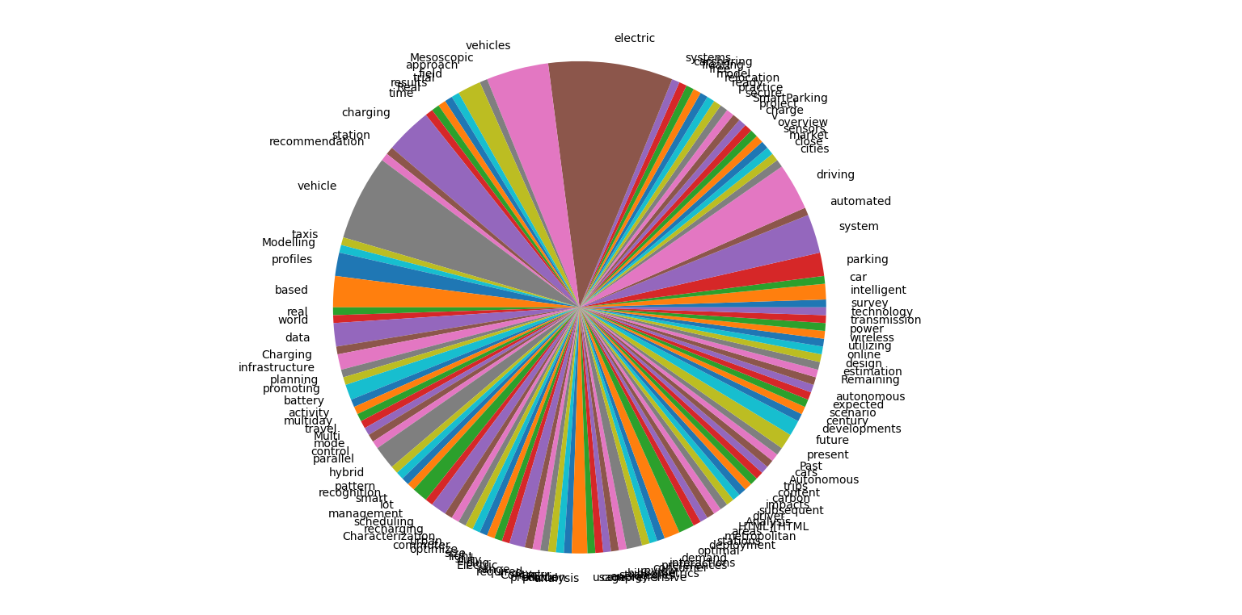

Figure 1

Using term frequency and inverse frequency document techniques, we get an idea of the weights of keywords: ’electric’, ’vehicles’, ’routing’ ,’parking’ and ‘system’ ,results for which can be seen in Figure 2 to 8:

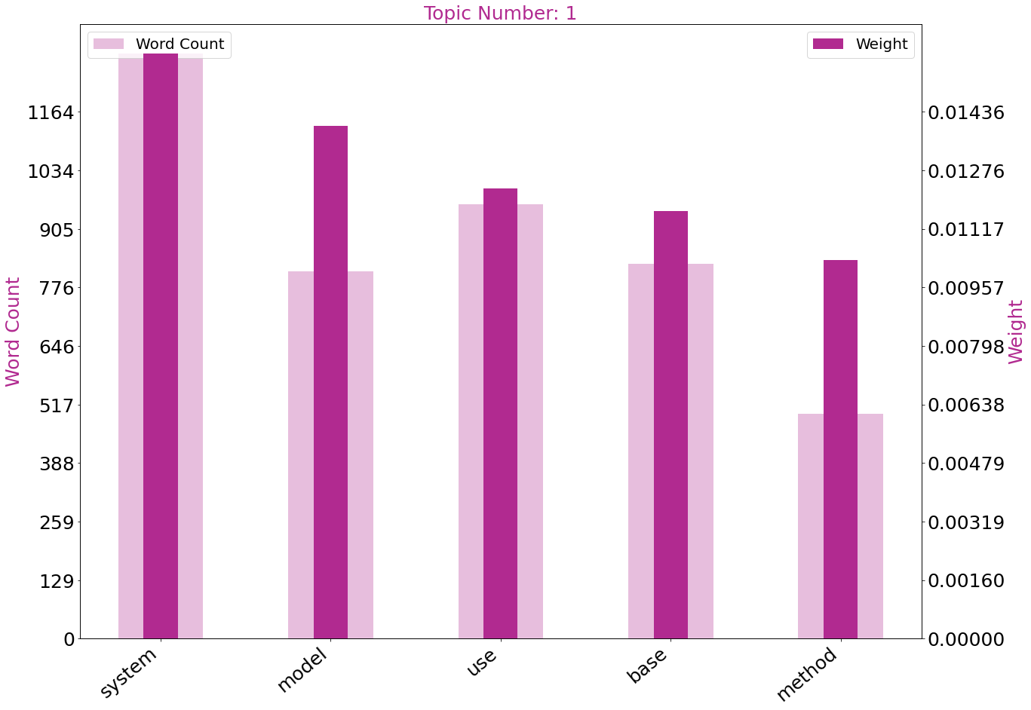

Figure 2:Keyword:’electric’

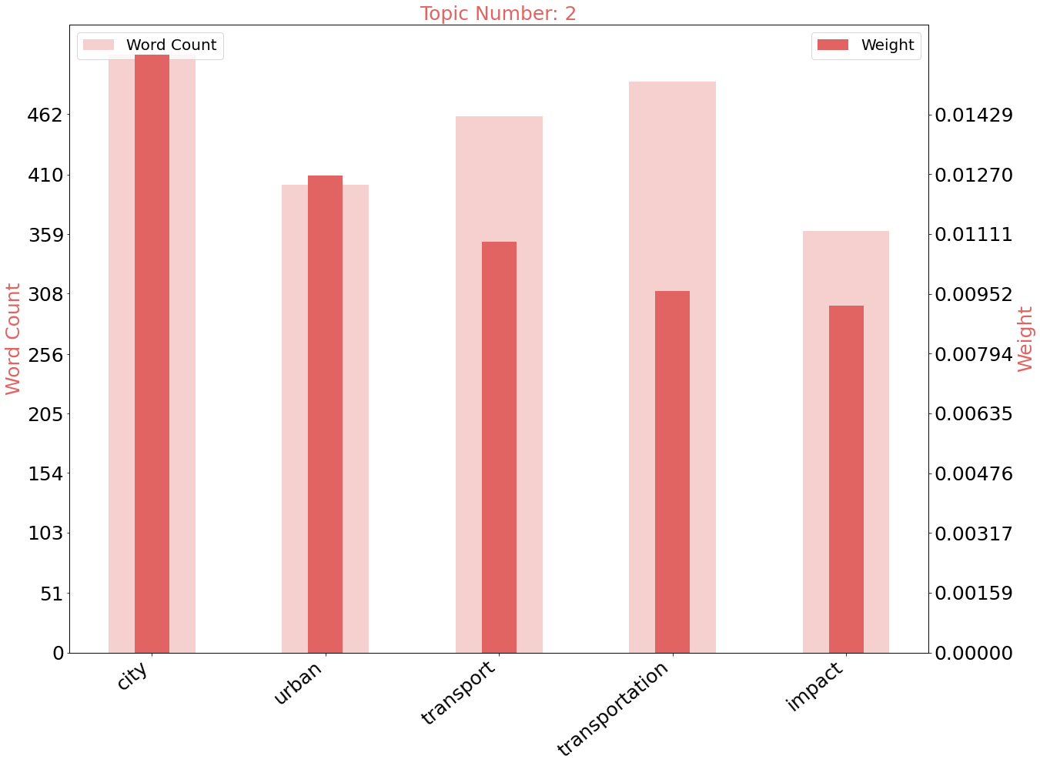

Figure 3:Keyword:’vehicles’

As increased number of papers made use of keyword ’routing’, it’s occurrence can be found in an additional 680 papers for relating words.

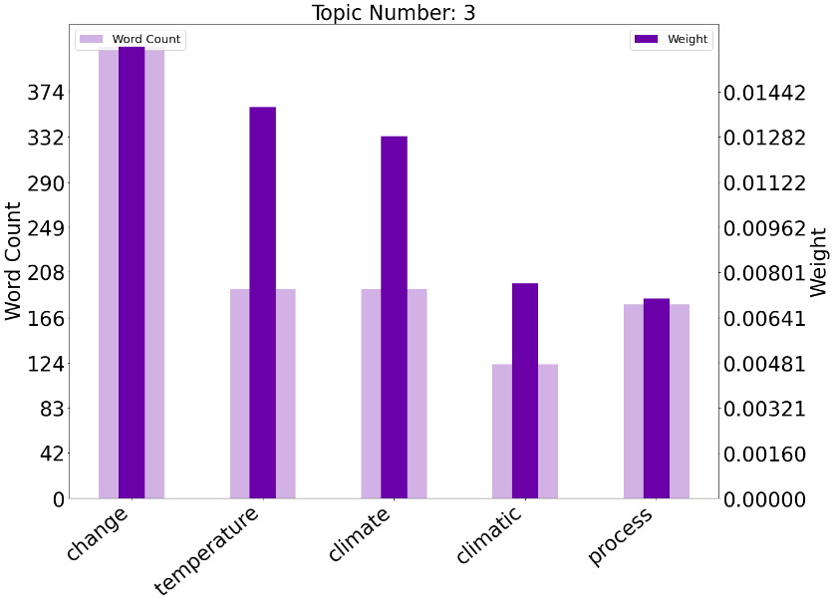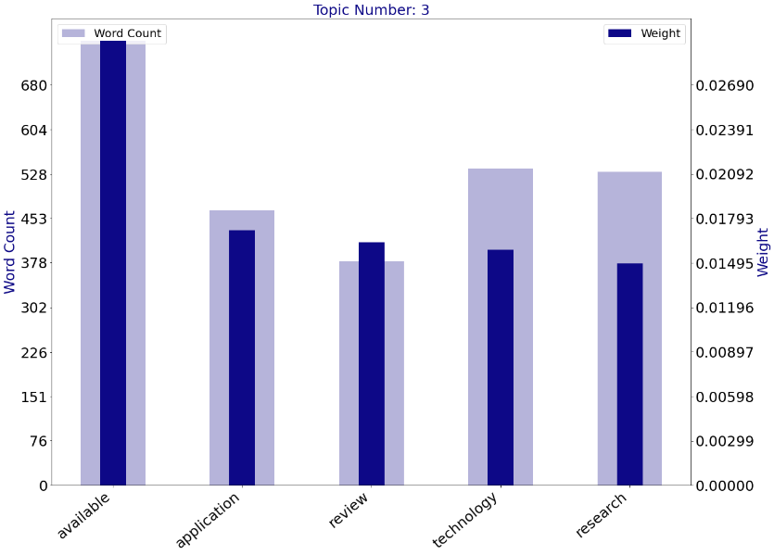

Figure 4 and 5:Keyword-‘routing’

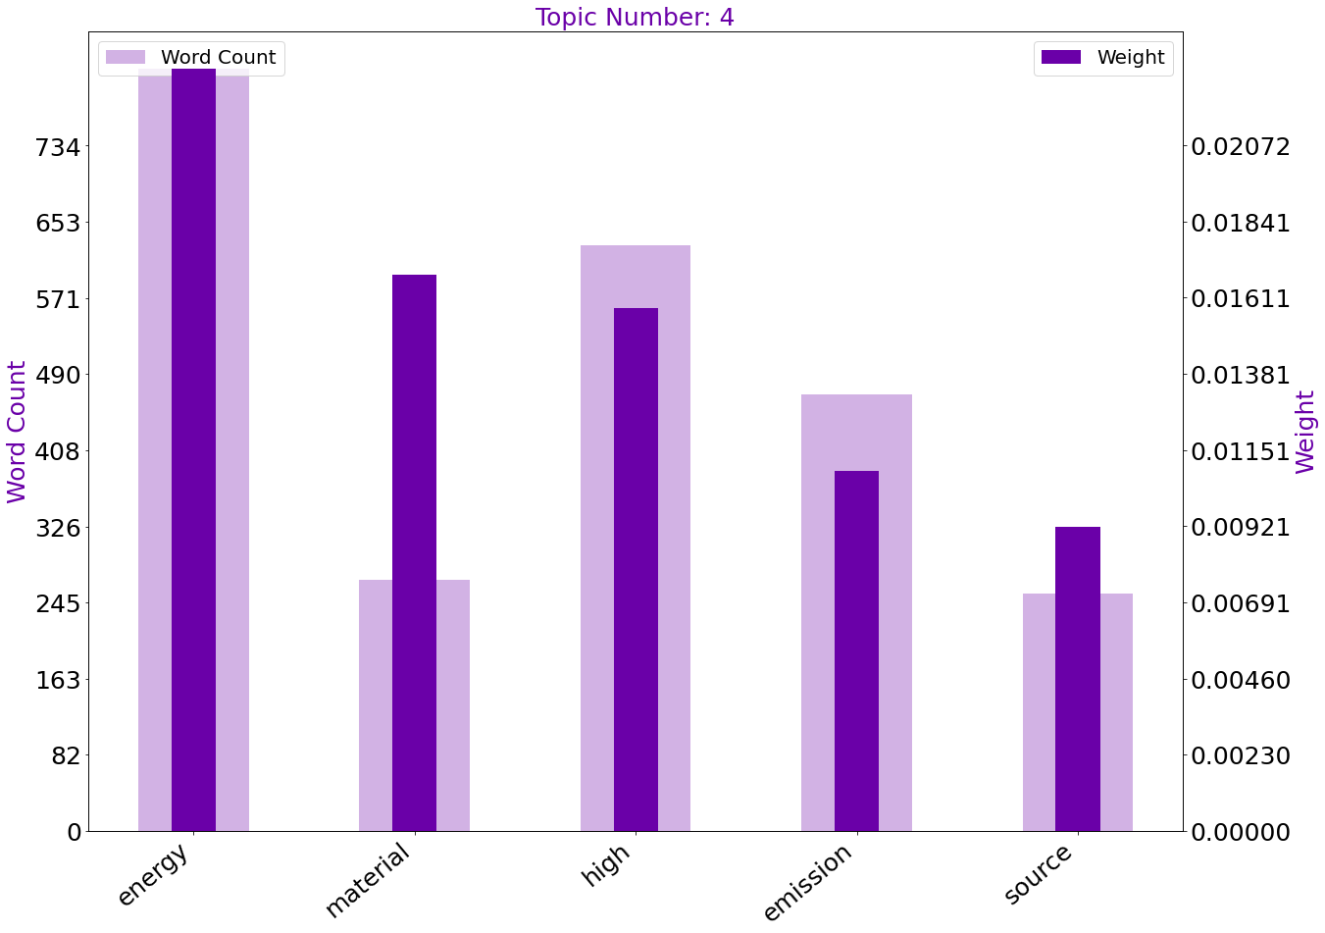

Figure 6:Keyword:’parking’

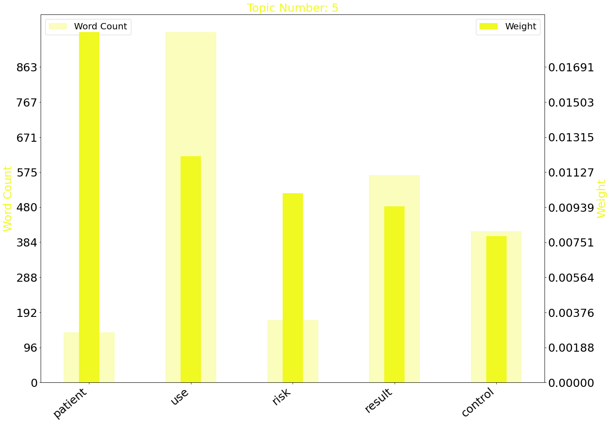

Figure 7:Keyword-‘system’

After computing all references,pre-processing and tokenizing the sysnonyms of keywords,the bar chart gives us the most significant demographic of words in figure 8 applied in the project:

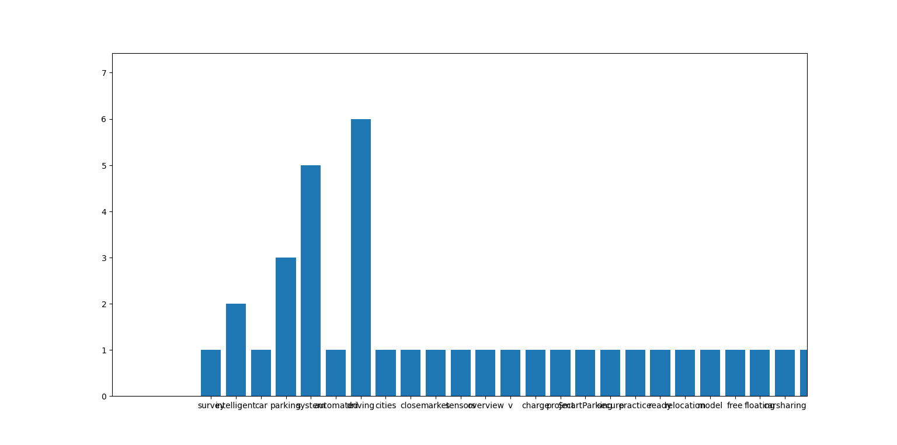

Figure 8:Bar Chart denoting ‘driving’ as most significant keyword relation

Figure 9 shows the scatter plot denoting the frequencies of the keyword:

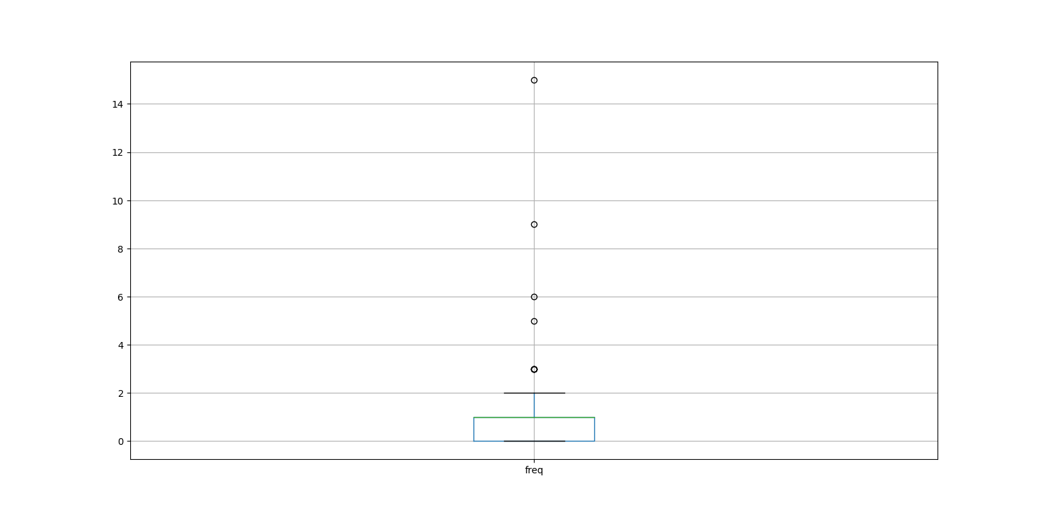

Figure 9:Keyword ‘electric’ has the most common occurrence of stated keywords

**DATASET**:We use an open-source API named OpenChargeMap which allows us to access the public registry containing name and address of every Electric Vehicle Charging Ports locations and form a database by using RESTful calls and formatting them into .csv format.We proceed to use Google’s geocoding API,which is by passing requests to an asynchronous geocoding function.

We pass a callback method to give a latitude and longitude result. To request contains information regarding address, location, ID of place, bounds, component Restrictions and region in string format. We record the latitude/longitude coordinates and append them into our database. Finally, our database head portion would take the following data into consideration:

|  |  |
| --- | --- |
|  |  |

The API provides useful information on 1548 EV Charging stations in the country of India. By using the ‘state’ entries as filter along with mapping option set to the same parameter, we generate dot markers with State, City, Name and Address as text labels.We pass Longitude as a column vector and Latitude as Row vector to get a dot plot on the map of India denoting the locations of all EV stations in India,as shown in Figure 10.

Figure 10

We proceed to plot a bar chart with State as column vector and using the count of names of the EV Stations along with color-coding of the States. Finally ,we see that Maharashtra, Tamil Nadu and Karnataka are 3 states with dominant number of electric vehicle charging stations(259,155 and 134).,as denoted by Figure 11 and 12.Same chart shows Andaman, Jammu and Kashmir and Uttarakhand with the lowest number of stations with 1 each.

Figure 11

Figure 12

We then form a tree map as shown in Figure 13 by color-coding the State parameter ,adding a text label of the names of states and marking the squares with the count of EV Charging stations to further solidify our findings from Figure 11 and 12.

Figure 13

The pie-chart in Figure 14 which was made by state-color-coding and sector counts for charging stations are further evidence of visualization confirming the metrics of state-based data.

Figure 14

For city-wise researching ,we use a packed bubble visualization which uses 2 Dimension metrics for City and State and measure parameter as the count of stations in India. Our inference is that Delhi has the highest amount of charging stations in India as compared to other cities ,as shown in Figure 15.

Figure 15

For the treemap, we used state count as measure variables and cities as color codes and text labels.

Figure 16

Figure 17

Finally, we made bar charts with sub-charts giving us a count of the exact number of charging stations in all cities of India .Highest amount of stations were found in Delhi (72) with the lowest count in Ujjain and Tirupati (1).

We proceed to make a heat map showing the overall frequencies in various regions of India with a high number found in the southern states, low numbers found in the deccan regions and east India and high abundance near in Northern states as shown in Figure 18(scaled on 1x Zoom) and 19(scales on 1.5x zoom-showing dot coordinates for some stations).

Figure 18

Figure 19

As part of our visualization phase, we vertically routed all charging stations to show connectivity throughout the country as shown in Figure 20.

Figure 20

1. IMPLEMENTATION OF ROUTING AND PARKING SYSTEM

Our project makes use of 3 APIs: Google Geocoding API to generate coordinates for source and origin, OpenStreetMap to integrate map tile for our server-side program and HERE API to make use of Electric Vehicle Routing from Point A to Point B.

We started by creating our command line program which would run the main script. An argument parser was integrated to carry out 5 functions:

1.Locate Coordinates from Address: We used the ‘geopy’ package in python n environment to accept an address as parameter which would call on the geocoding functions to print the Latitude and Longitude coordinates of the address as long as it is a valid address with no spelling errors.

2.Locate Address from Coordinates: This function did the opposite from the first function as it would give an address by giving latitude-longitude coordinates.

3.Great Circle Distance Calculator: Great Circle is the shortest distance between any two places on a sphere's surface when measured along the sphere's surface rather than in a direct line through the centre of the sphere. The length of a straight line connecting any two points in Euclidean space represents their distance, however there are no straight lines on the sphere. Geodesics are used in place of straight lines in curved spaces. Geodesics on the sphere are referred to as "great circles" and are circles on the sphere whose centres match the sphere's center.This function allows user to take 2 inputs as source and destination and calculate the Great Circle distance in kilometers.

4.Geodesic Distance Calculator:The number of edges in the shortest path (also known as a graph geodesic) between any two points in a graph is the geodesic distance between them. This function allows user to take 2 inputs as source and destination and calculate the Geodesic distance in kilometers.

5.Server Configuration: This function accepts 2 locations as origin and destination ,calculates it’s coordinates in latitude-longitude forms and configures data in our backend code and finally opens a new tab showing the best possible route,along with total time (depending on realtime traffic conditions) to reach destination,the program also shows time which would take at charging stations so that the EV completes its journey.

6.Terminal Mode and Sample Mode:The user can switch between using a predefined set of destinations(sample mode) or provide any origin and destination information on their own(terminal mode).

Our python script interacts with our server-side javascript code by changing location details and opening a browser tab. The server-side code structure is as follows:

We create a route function which accepts origin-destination data along with the amount of charge in the EV (in percentage).Inside the function we define a embedded json-array which would contain pre-defined data on destinations based in India which contains ID (primary-key),value(short form of destination),full name of destination and latitude-longitude coordinates.If the API detects a proper route based on information gathered,it will show the timings,route directions and steps to take on a separate panel on the browser tab else it would return result as ‘No Route Available.’

To implement the functions we have designed, we will need 4 elements: a map, an initial route planner, a database of charging stations and finally a component that takes care of combining the route provided with the position of the columns to generate the route

This allows to monitor EV status and control it remotely with any stops.

The user on interacting with the command line based python script will provide information and invoke a path request which will involve the functions responsible for finding and generating the paths. The user will enter the origin point and the destination point and may choose charge capacity from the dropdown menu.The user should ensure that the locations are valid and see that the processed information is being sent correctly through OpenStreetMap and Google Geocoding API to convert addresses into coordinates and are successfully being sent into the server code.The received coordinates are then provided to OpenStreetMap to obtain the route between the 2 points.The route obtained from the data generates the definitive route and the result is presented to the user in satellite view,map view and realtime traffic view.The code won’t work if the 2 points are separated from each other by any water body or absence of road routes.

The units of State of Charge (SoC) denotes 0% as empty battery relative to capacity while 100% means full battery to charge meant for deployment on-road.The routing function checks maximum ascent angle as 90 degrees and maximum descent angle as 45 degrees with specified Charging voltages set at 400W 12V Automotive engines with maximum charge after charging at station set at 80%.An info bubble is defined to hold references to Position and content and holds details regarding province name and information regarding terrain and route instructions.A polyline function is added the route.2 additional functions are also made to add arrival and departing markers for easier visibility to the user.Charge stop details are added by adding Arrival Charge,Consmable Power,Duration and Target Charge after optimal route is defined.Finally,functions to show time in MM:SS format and HH:MM:SS fomat are added to calculate duration of time for travel from source to origin.

Additional features of the code will give you the time duration on-road and while in charging mode depending on the charge at a certain point of the journey.The code will also generate user instructions concerning turns and round-abouts between origin and destination. The instructions are generated by directionPanel and directionTitle attributes ,as defined by HERE API.The map is initialized with a zoom level of 5 over the coordinates of India.

Our second module is the Parking System which uses the heap data structure to facilitate storing and removing of EVs after they have been charged at their stations and returning it to the appropriate users of those vehicles. This system is based on the Flask framework where we introduce the login module which requires the user to log into the system with his/her credentials.The user would press the login button to send data and the system would reply by logging the user to the window.The module would respond with the same procedure when the user opts to log out. Since every charging station has a set amount of stations, we will allocate spaces for vehicles in the webpage in static manner to ensure that the environment matches the facility and emsure independence of the routing system by enabling only 2 credentials for usage by station manager.The module will build a heap upon entering the first vehicle details and would build until the facility doesn’t have any vacant stations left. The vehicle information will be taken out of the heap if the user intends to find his/her vehicle by entering it’s license plate details. The module will also give response if the EV is not in the premises.

To give location of EV,we define global variables for the heap,size of heap,an option flag for vacancy of parking slot(0 for empty and 1 for occupied) and if it is being used or not.We define a function to check if the car value is present in the heap,so that it can be taken out and it’s details can be accessed by the user.

1. CONCLUSION

On providing major route destinations across the demographic of India ,it was found that at maximum capacity, an electric vehicle commissioned for public usage can traverse routes till the extend of 150 kilometers on a single charge, provided that they are charged at their facilities at the end of their routine cycle of a day. As such ,while inter-city travel is shown as possible by using the routing module of the project,an electric vehicle will give out in the middle of the route in case of intra-city travels due to lack of electric vehicles in national highways in the country.The parking system would still allow seamless monitoring of electric vehicles and counteract theft and damage caused by accidents or reckless users and will save providers of high repairing costs.

FULL FORMS

• API-application programming interface

• ACO-Ant Colony OptimizatioN

• CWD-Charging-while-Driving

• CII-Confederation of Indian Industry

• EV-Electric vehicle

• ELRPIN-Electric Car Location Routing Problem with Intermediate Nodes

• EVRP-Electric Vehicle Routing Problem

• GIS-Geographic information systems

• ID-Identification

• IEA-International Energy Agency

• IOT-Internet of Things

• KM-kilometers

• MDP-Markov Decision Process

• NITI-National Institution for Transforming India

• PSO-Particle swarm optimization

• PPO-Proximal Policy Optimization

• PPP-Public-Private Partnerships

• SoC-State of Charge

• TERI-The Energy and Resources Institute

• V2G-Vehicle-to-Grid

• OD-origin-to-destination

References

[1] IEA (2019), Global EV Outlook 2019, IEA, Paris https://www.iea.org/reports/global-ev-outlook-2019, License: CC BY 4.0

[2] Electric Vehicle Industry in India might continue to draw investments <https://www2.deloitte.com/in/en/pages/finance/articles/ev-covid.html>

[3] E-MOBILITY: NATIONAL MISSION ON TRANSFORMATIVE MOBILITY AND BATTERY STORAGE <https://www.niti.gov.in/e-mobility-national-mission-transformative-mobility-and-battery-storage>

[4] Faster adoption of electric vehicles <https://www.teriin.org/sites/default/files/2019-11/Faster%20adoption%20of%20electric%20vehicles%20in%20India>

[5] Corona-Gutiérrez, K., Nucamendi-Guillén, S., & Lalla-Ruiz, E. (2022, March 5). Vehicle routing with cumulative objectives: A State of the art and analysis. Computers & Industrial Engineering.

[6] Electric-Vehicle Routing Planning Based on the Law of Electric Energy Consumption Nan Ding 1 , Jingshuai Yang 1,*, Zhibin Han 1 and Jianming Hao

[7] Foa, S. (2022, July 30). Solving the vehicle routing problem with deep reinforcement learning. arXiv.org. https://arxiv.org/abs/2208.00202

[8] Rajesh, K. (2022, August 26). A Multi-Objective approach to the Electric Vehicle Routing Problem. arXiv.org. https://arxiv.org/abs/2208.12440

[9] Qin, Hu & Su, Xinxin & Ren, Teng & Luo, Zhixing. (2021). A review on the electric vehicle routing problems: Variants and algorithms. Frontiers of Engineering Management. 8. 10.1007/s42524-021-0157-1.

[10] L. P. Qian, X. Zhou, N. Yu and Y. Wu, "Electric Vehicles Charging Scheduling Optimization for Total Elapsed Time Minimization," 2020 IEEE 91st Vehicular Technology Conference (VTC2020-Spring), 2020, pp. 1-5, doi: 10.1109/VTC2020-Spring48590.2020.9128915.

[11] Dorokhova Marina, Ballif Christophe, Wyrsch NicolasRouting of Electric Vehicles With Intermediary Charging Stations: A Reinforcement Learning Approach, Frontiers in Big Data -2021

[12] S. Shahriar, A. R. Al-Ali, A. H. Osman, S. Dhou and M. Nijim, "Machine Learning Approaches for EV Charging Behavior: A Review," in IEEE Access, vol. 8, pp. 168980-168993, 2020, doi: 10.1109/ACCESS.2020.3023388.

[13] The Consistent Electric-Vehicle Routing Problem with Backhauls and Charging Management - ScienceDirect.” ScienceDirect.Com | Science, Health and Medical Journals, Full Text Articles and Books., https://www.sciencedirect.com/science/article/pii/S037722172 2000455. 2022.

[14] Ye C, He W, Chen H. Electric vehicle routing models and solution algorithms in logistics distribution: A systematic review. Environ Sci Pollut Res Int. 2022 Aug;29(38):57067-57090. doi: 10.1007/s11356-022-21559-2. Epub 2022 Jun 25. PMID: 35752674.

[15] D. Rezgui, H. Bouziri, W. Aggoune-Mtalaa and J. C. Siala, "A Comparative Study of Local Search Techniques Addressing an Electric Vehicle Routing Problem with Time Windows," 2020 International Multi-Conference on: “Organization of Knowledge and Advanced Technologies” (OCTA), 2020, pp. 1-5, doi: 10.1109/OCTA49274.2020.9151852.

[16] A. R. Daanish and B. K. Naick, "Implementation of charging station based electric vehicle routing problem using nearest neighbour search algorithm," 2017 2nd IEEE International Conference on Intelligent Transportation Engineering (ICITE), 2017, pp. 52-56, doi: 10.1109/ICITE.2017.8056880

[17] S. Hulagu and H. B. Celikoglu, "Electric Vehicle Location Routing Problem With Vehicle Motion Dynamics-Based Energy Consumption and Recovery," in IEEE Transactions on Intelligent Transportation Systems, vol. 23, no. 8, pp. 10275-10286, Aug. 2022, doi: 10.1109/TITS.2021.3089675.

[18] A. I. Aygun and S. Kamalasadan, "An Optimal Approach to Manage Electric Vehicle Fleets Routing," 2022 IEEE International Conference on Power Electronics, Smart Grid, and Renewable Energy (PESGRE), 2022, pp. 1-6, doi: 10.1109/PESGRE52268.2022.9715894.

[19] M. Thymianis, A. Tzanetos, E. Osaba, G. Dounias and J. Del Ser, "Electric Vehicle Routing Problem: Literature Review, Instances and Results with a Novel Ant Colony Optimization Method," 2022 IEEE Congress on Evolutionary Computation (CEC), 2022, pp. 1-8, doi: 10.1109/CEC55065.2022.9870373.

[20] Zhang, C.; Zhao, Y.; Leng, L. A Hyper Heuristic Algorithm to Solve the Low-Carbon Location Routing Problem. Algorithms 2019, 12, 129. https://doi.org/10.3390/a12070129

[21] Ahsan, Zishan & Bo, Ding & Cai, Zhenfei & Wen, Cuie & Yang, Weidong & Ma, Yangzhou & Zhang, Shihong & Song, Guangsheng & Javed, Muhammad Sufyan. (2020). Recent Progress in Capacity Enhancement of LiFePO4 Cathode For Li-ion Batteries. Journal of Electrochemical Energy Conversion and Storage. 18. 1-54. 10.1115/1.4047222.

[22] Wang, Hua & Zhao, De & Cai, Yutong & Meng, Qiang & Ong, Ghim. (2021). Taxi trajectory data based fast-charging facility planning for urban electric taxi systems. Applied Energy. 286. 116515. 10.1016/j.apenergy.2021.116515.

[23] Liao, Jian-Tang & Huang, Hao-Wei & Yang, Hong-Tzer & Li, Desheng. (2021). Decentralized V2G/G2V Scheduling of EV Charging Stations by Considering the Conversion Efficiency of Bidirectional Chargers. Energies. 14. 962. 10.3390/en14040962.

[24] Guangyou Zhou, Zhiwei Zhu, Sumei Luo,Location optimization of electric vehicle charging stations: Based on cost model and genetic algorithm,Energy,Volume 247,2022,123437,ISSN 0360-5442,https://doi.org/10.1016/j.energy.2022.123437.

[25] Rimal, B.P.; Kong, C.; Poudel, B.; Wang, Y.; Shahi, P. Smart Electric Vehicle Charging in the Era of Internet of Vehicles, Emerging Trends, and Open Issues. Energies 2022, 15, 1908. https://doi.org/10.3390/en15051908

[26] Velimirović, L.Z., Janjić, A., Velimirović, J.D. (2023). Electric Vehicle Charging Optimization. In: Multi-criteria Decision Making for Smart Grid Design and Operation. Disruptive Technologies and Digital Transformations for Society 5.0. Springer, Singapore. https://doi.org/10.1007/978-981-19-7677-3_11

[27] Khan, P.W.; Byun, Y.-C. Blockchain-Based Peer-to-Peer Energy Trading and Charging Payment System for Electric Vehicles. Sustainability 2021, 13, 7962. https://doi.org/10.3390/su13147962

Authors

**First Author** – Aryaman Mishra.B.Tech CSE,VIT Chennai, aryaman.mishra2019@vitstudent.ac.in

**Second Author** – Prof. Suguna M,Assistant Professor,VIT Chennai